How do I create child accounts?
If you're a parent and you already have a Khan Academy account, you can visit khanacademy.org/parent and click the "Add your child" button. (If you don't have an account for yourself yet, go to www.khancademy.org to create one.)
Once you click "Add your child," you will be asked for your child's birthdate:
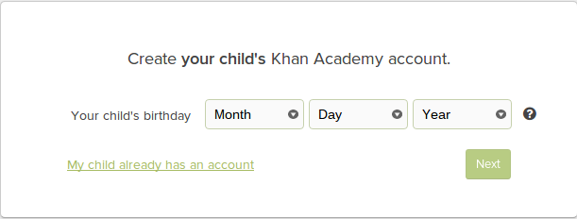
Your child's birthday is needed to determine permissions available. Accounts for students under 13 are managed by a parent to protect the child's privacy. You can find more information about accounts for students under 13 here.

If your child is under age 13:
You will get a form to fill out for your child (note the account is a restricted child account):
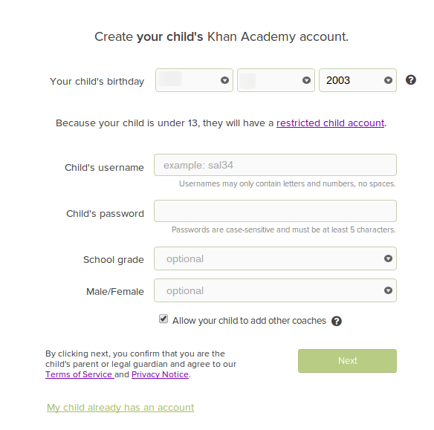
Fill out the form and click Next to create the account.
If your child is age 13 or over:
You will be asked if your child has an email address. If your child has an email address you may either send your child an invitation to join Khan Academy, or you could create the account for your child:
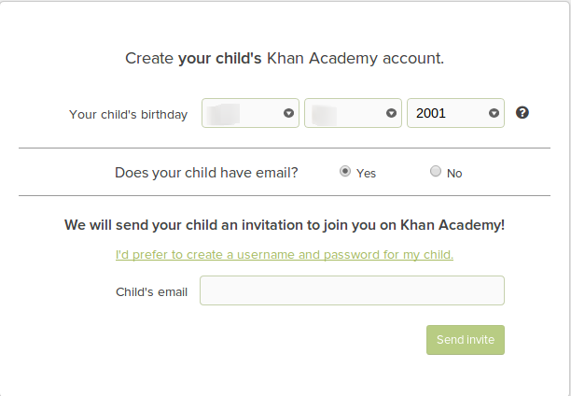
If your child does not have an email address (or your choose to create the account yourself) you will get a form similar to the form if your child were under 13:
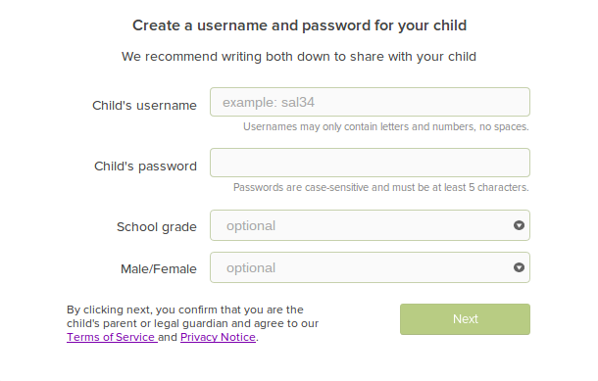
Fill out the form and click next.
Multiple children
If you have more children you can continue creating accounts now by clicking "Add another child."
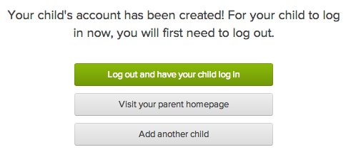
or you can click "Add your child" from your parent homepage at any time.
After account creation
After you have created your child account(s) you can return to your homepage and log out and your child can log into his/her account. Always remember to log out of your account when you are done using it and teach your child to do the same.

